Characteristics of the Program
Colombia would benefit significantly from increased energy efficiency – but the market is currently underserved. The market studies on energy efficiency barriers undertaken during the preparation of this operation identified that one of the most important barriers for financing technologies was the lack of trust: by potential beneficiaries. They did not believe that EE investments would actually result in enough energy savings so as to repay the initial investment in a reasonable period of time.
Local Financial Institutions (LFIs) also tend to apply a traditional “asset-based” lending approach when financing energy efficiency projects, limiting the loan amount to a maximum of 70%-80% of the value of assets financed (or collateral provided). Unfortunately, LFIs give little or no collateral value to EE equipment. Furthermore, even though there is significant value in the cash flow generated by energy efficiency investment projects to investing firms, most LFIs typically do not recognize and/or are not willing to rely upon that cash flow as a basis for those firms to repay their loans or increase their borrowing capacity. Furthermore, even if they would accept to consider such value, the incapacity to validate the risks involved in the generation of these positive cash flows would still refrain them from considering energy efficiency projects as financially viable business opportunities. Consequently, LFIs tend to assign little or no value to the cash flow generated by EE investment projects, and thus require firms to encumber their internal credit capacity to finance such projects.
The lack of understanding by clients and LFIs regarding the potential returns of energy savings, the high perceived risk of new more efficient technologies, and the need to secure external guarantees of a certain level of energy savings (mistrust in the performance of EE projects and EE audits) are actually typical barriers for investments in energy efficiency projects in many countries. In some countries, such as the United States of America, in order to address this barrier, these types of investments are directly undertaken by specialized Energy Service Companies (ESCOs) under a performance contract. The performance-based contracts are commonly used in the industry and recognized by the US government (not the case in Colombia).
ESCOs provide a wide verity of services such as: Identify and evaluate energy-saving opportunities; develop engineering designs and technical specifications; arrange external financing and/or provide financing themselves; provide monitoring and maintain the system to ensure energy savings during the payback period; The savings in energy costs are often used to pay back the capital investment of the project over a five- to ten-year period. If the project does not provide the projected returns on the investment, the ESCO is often responsible to pay the difference.
Colombia does not have an effective ESCO sector, and barriers currently exist to its development . Market studies have shown that while Colombia has many companies that can provide advisory services on energy efficiency, most of them do not have enough capital to invest directly in buying the technologies and taking the risks associated with EE projects. Only two companies were identified as “Energy Service Providers” (ESPs, i.e. companies that are directly investing in EE projects under performance contracts – and could be precursors to ESCOs in the future), but their capacity to expand their exposure in this type of projects is limited by their narrow capital base.
Given the impossibility to rely on the ESCO model in Colombia, the studies undertaken have shown that in order to promote energy efficiency investments in the country the following barriers / issues would need to be addressed:
- Technical: Clients and LFIs need to have independent assurances that the providers of technical services and technologies have the technical expertise and equipment’s, respectively, to support the structuring and implementation of successful energy efficiency projects, and are able to provide the warranties.
- Legal: The contractual arrangements between clients and service providers need to be transparent and standardized with regards to what type of services are provided, how service providers guarantee the performance of their EE projects, and what is the arbitration and remedies if promised savings do not materialize.
- Insurance: Clients need to be offered compensation / insurance schemes in case the promised financial flows (return on the investment) associated with energy savings do not occur.
- Standards: There also exists the need to have clear standards for monitoring and verifying energy savings, and a reliable system to carry out these two very important activities.
In order to promote an enabling environment that addresses the aforementioned issues and risk perceptions of potential beneficiaries and LFIs, the proposed program, through the coordinating efforts of Bancoldex, would provide the following incentives:
- Technical backstopping by energy services providers to beneficiary firms (which should be amortized through the credit line itself) in order to support ESPs to: i) estimate potential energy savings, ii) design eligible projects; iii) develop monitoring plans and iv) measure and report energy savings and greenhouse gas (GHG) emissions reductions achieved.
- Investment financing at terms and conditions that take into account the costs and returns of EE investment projects (which will be defined based on studies under way)
- Risk management tools through: i) a third party verifier that will assess both: a) the technical quality and expected results of project proposals made by technical services providers, and b) the technical expertise of those providers; and ii) the design of the contractual arrangements required by a performance insurance policy to be developed by a local insurance company in order to insure firms investing in EE against shortfalls in agreed energy savings during the loan repayment period of their EE investment.
In addition to the concessionality of the credit line (particularly in terms of loan repayment periods), the program would fund, through a complementary technical cooperation, the following interventions that would support both the supply of and the demand for financing for EE investment projects:
- Development of standard contractual terms that could fit in a recognized legal construction contract and which should establish the rights and obligations of both beneficiary firms and technical services providers, specifying, among other things, the project design and execution services that technical services providers would provide, the payment system and schedules, the arbitration and penalty systems that would be triggered if promised energy savings do not materialize, and the guarantees that technical service providers would have to extend to beneficiary firms to ensure that the latter are not financially affected if the EE project does not delivered the benefits that it is supposed to deliver. This intervention will include the discussions of the clauses and contract terms with the different stakeholders (clients, energy service providers, LFI, insurance company, third party verification organization, and Bancoldex), with the aim to develop a widely-accepted standardized contract. The contract will guarantee a reliable and fair agreement between the client and the Energy Service Provider, and this can help to create confidence among the partners. The contract has to be reviewed and endorsed by a recognized local legal expert before the discussions process. The standard contractual clauses will be made transparently available to any beneficiary firms and service providers that wish to participate in the program.
- Development of the methodologies, protocols and the system for monitoring, validation and verification of results (including monitoring the performance), by a third party to be hired by Bancoldex. Such independent third party would also assess the technical expertise of the technical services providers, the quality of the project proposals developed by them (including their technical design and their expected energy savings), and their project monitoring plans and performance reports. The third party will further assess with onsite visits whether projects have installed proposed equipment, have implemented monitoring requirements and have undertaken necessary measures to dispose and decommission the old equipment replaced.
- Development of a payment scheme for technical service providers that provides incentives for high quality support. Such scheme should contemplate: i) a partial payment when the technical and financial proposal is validated by an independent technical third party and the investment loan is granted to the beneficiary firm to cover investment costs; and ii) semi-annual or annual performance payments based on the achievement of the promised energy savings once the project starts its execution phase. The cost of the technical services would be financed by the credit line itself.
- Development of an insurance policy to cover the risks associated to the technical services to be provided by the technical services providers as well as other potential performance related issues. The performance insurance policy would be acquired and paid for by the technical services providers and the beneficiary would be the firms making the investment and assuming the loan for such investment. The policy would ensure that if the project does not achieve the level of energy savings promised at the beginning of the project, given an agreed level of activity, the beneficiary firm would receive a monetary compensation equivalent to the difference between the promised energy savings at the beginning of the period and the actual energy savings of any given period, multiplied by the agreed price of energy at the beginning of the execution of the project.
- Design and implementation of a strategy to promote the program to potential beneficiary clients (including the full technical design of some bankable project proposals to pilot the proposed financing scheme). This intervention will include the demonstration of the economic benefits of energy efficiency projects in market-representative hotels and hospital (SMEs). In order to develop this activity five energy audits will be funded with the aim to use the output information as awareness-raising material (this information is normally confidential, so the objective to pay for the EE audits is to own the data, and use it as a promotion material). A second goal of this phase is to use the energy audits as catalysts to implement the EE projects (demonstrative projects) for the LFI, Insurance, ESCO, and clients and engage them in executing the projects. The final objective of this intervention is to stimulate the demand (clients) to invest in EE projects, and as a learning process for the stakeholders.
The proposed scheme would initially be piloted in the hotel and clinics/hospital sub-sectors. These sub-sectors were selected to pilot the program’s proposed financing strategy because GHG emissions reductions, though relatively smaller than in other sectors, could be achieved more cost-effectively and because they could have strong demonstration and replication effect not only in these sub-sectors but also in the services sector. Indeed, it is expected that if the program succeeds, the combination of adequate financial terms with risk mitigation instruments and technical support to support the development of the demand-side of the market could be replicated in other productive sectors. This would provide an alternative financing model to the ESCO model in a country where technical services provides operating under such scheme are practically inexistent. Finally other interventions envisaged to promote investment by private sector in energy efficiency measures in the Colombian Investment Plan are expected to complement this operation support expansion and further promotion of this model and capacity of energy services providers in Colombia.
A detailed description on how the two-phase financing scheme would operate is presented in what follows.

Phase 1: Project validation and credit approval:
Step 1: The service provider undertakes energy diagnostic to assess energy savings potential. If that potential is attractive, the energy services provider signs a contract with the client – based on the standard contract provided by Bancoldex.
Step 2: The technical service provider prepares a technical and financial project proposal, following a standard template provided by Bancoldex. The proposal will contain the potential energy savings and GHG emission reductions expected from the project.
Step 3: Based on the technical and financial project proposal, the beneficiary firm or the technical services provider on its behalf makes a credit/lease application in a LFI.
Step 4: After assessing and accepting to take the firm’s risk and the project’s financial risk, the LFI requests Bancoldex to assess, through an independent third party, the proposal’s technical risk and the technical expertise of the technical services provider.
Step 5: Bancoldex remits the project proposal to a qualified external validator contracted by it to review the technical quality of the project proposal and the technical expertise of the technical service provider that prepare it. Based on a previously defined methodology developed for program, the validator makes a technical assessment if the proposed measures and technologies are appropriate and can generate the savings estimated by the technical services provider in his/her proposal. The validator will also assess whether the technical services provider has the necessary technical competencies to support the detailed design of the program and its subsequent implementation.
Step 6: The validator provides its assessment of the project proposal of the technical services provider to Bancoldex, and if the assessment is positive Bancoldex approves the funding for the project to the LFI.
Step 7: Based on the validation of the project proposal and of the technical services provider Bancoldex disburses the resources to the LFI.
Step 8: The commercial bank disburses the credit to the client. 6 months after disbursement the Third party validator / verifier will spot check whether equipment has been installed, the monitoring plan and measures are correctly being put in place and the old equipment has been decommissioned. Failure by the client to address any of these issues would result in the obligation to return the credit to the LFI/ Bancoldex.
Step 9: The technical services provider develops and sends to the external validator contracted by Bancoldex the detailed design of the project operations and maintenance and prepares a monitoring plan that will include how the energy savings and GHG emissions reductions will be estimated, monitored and reported. At this point the technical services provider gets a partial payment from the beneficiary firm for the detailed design of the project. The remaining payments would be based on the project performance during the execution phase
Step 10: The validator reviews the monitoring plan and validates it.
Step 11: The technical services provider buys a performance insurance policy from a local insurance company to cover the risks associated with the technical performance of the project. The beneficiary is the firm making the investments and assuming the loan.
Step 12: The beneficiary firm receives a performance insurance policy to cover potential technical risks.
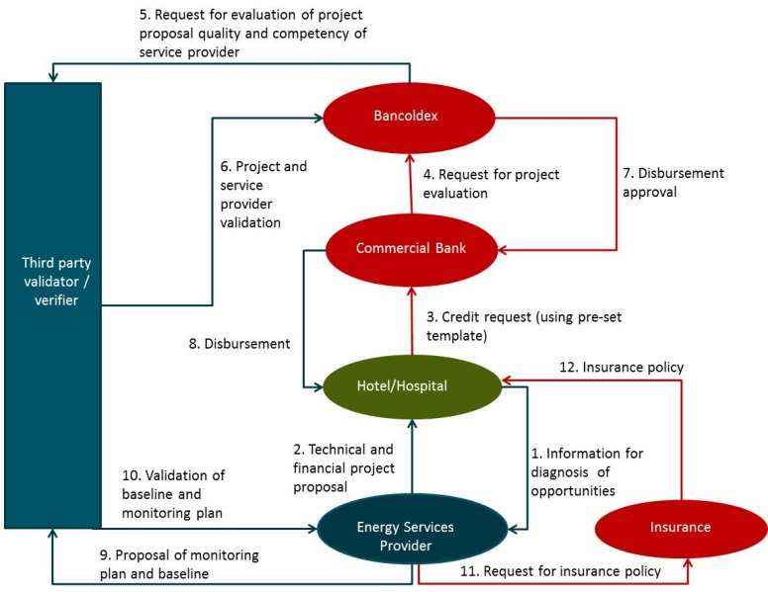
Phase 2: Implementation, monitoring and reporting
Step 1: The technical services provider prepares periodic reports on the energy savings achieved by the project that are submitted to the beneficiary firm. The energy savings reports are the basis under which technical service providers would get paid by beneficiary firms during the execution phase.
If the client agrees with the energy savings report received from the technical services provider:
Step 2: The beneficiary firm pays the technical services providers a previously established percentage of his/her contract amounts.
Step 3: The beneficiary firm, or the technical services provider on his behalf, sends to Bancoldex the monitoring report (using a standard template). Reports should be sent at least once a year during the beneficiary firm’s loan repayment period)
Step 4: Bancoldex maintains the reports in an electronic registry system that estimates the overall amount of energy savings and GHG emission reductions that are being achieved by individual projects. This registry will be used as the basis for the impact evaluation of the program.
If the beneficiary firm does not agree with the energy savings report received from the technical services provider:
Step 2 bis: The beneficiary firm sends the report to an external verifier contracted by Bancoldex to review the monitoring reports.
Step 3 bis: The verifier assesses the energy savings report and determines the actual energy savings generated by the project.
Step 4 bis: In case the verifier assessment concludes that the energy savings were below those promised by the technical services provider to the beneficiary firm at the beginning of the project, the beneficiary firm does not pay the technical services provider the performance payment that he/she was scheduled to receive in that period. If such amount is not enough to cover the shortfall in energy savings, the beneficiary firm can make a claim on the performance insurance policy for the difference.
Step 5 bis: The client sends the final agreed monitoring report (with necessary revisions, if recommended by the verifier, and using a standard template) to Bancoldex. (Energy savings reports should be sent at least once a year)
Step 6 bis: Bancoldex maintains the reports in an electronic registry system that estimates the overall amount of energy savings and GHG emission reductions that are being achieved by individual projects. This registry will be used as the basis for the evaluation of the program.

