Map 1: Diesel Generation in ZNI (source: IPSE, 2014)

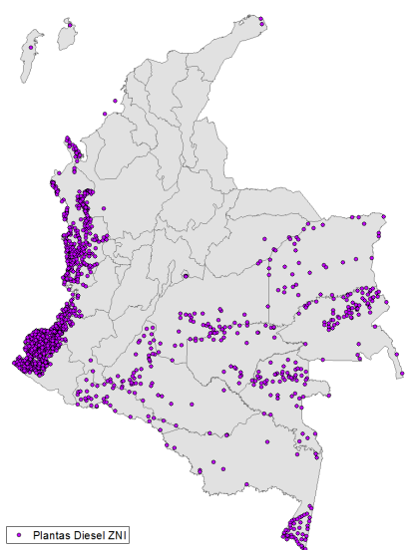

Map 2: Levels of electricity coverage in Colombia (source: UPME, 2014)
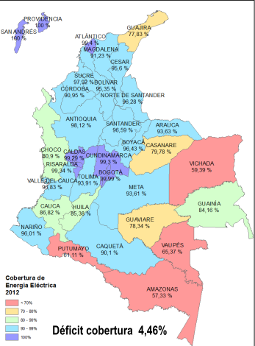

Figure 3: Indicative Energy Coverage Expansion Plan by Localities (source: UPNE, 2014)

